Supplementary Instructions for Atomic Anchorlox® - Locking Nut/Bolt kits.

The following instructions are to be followed when replacing factory Stud and Nut fastening systems with Anchorlox Bolt kits.

Step 1.
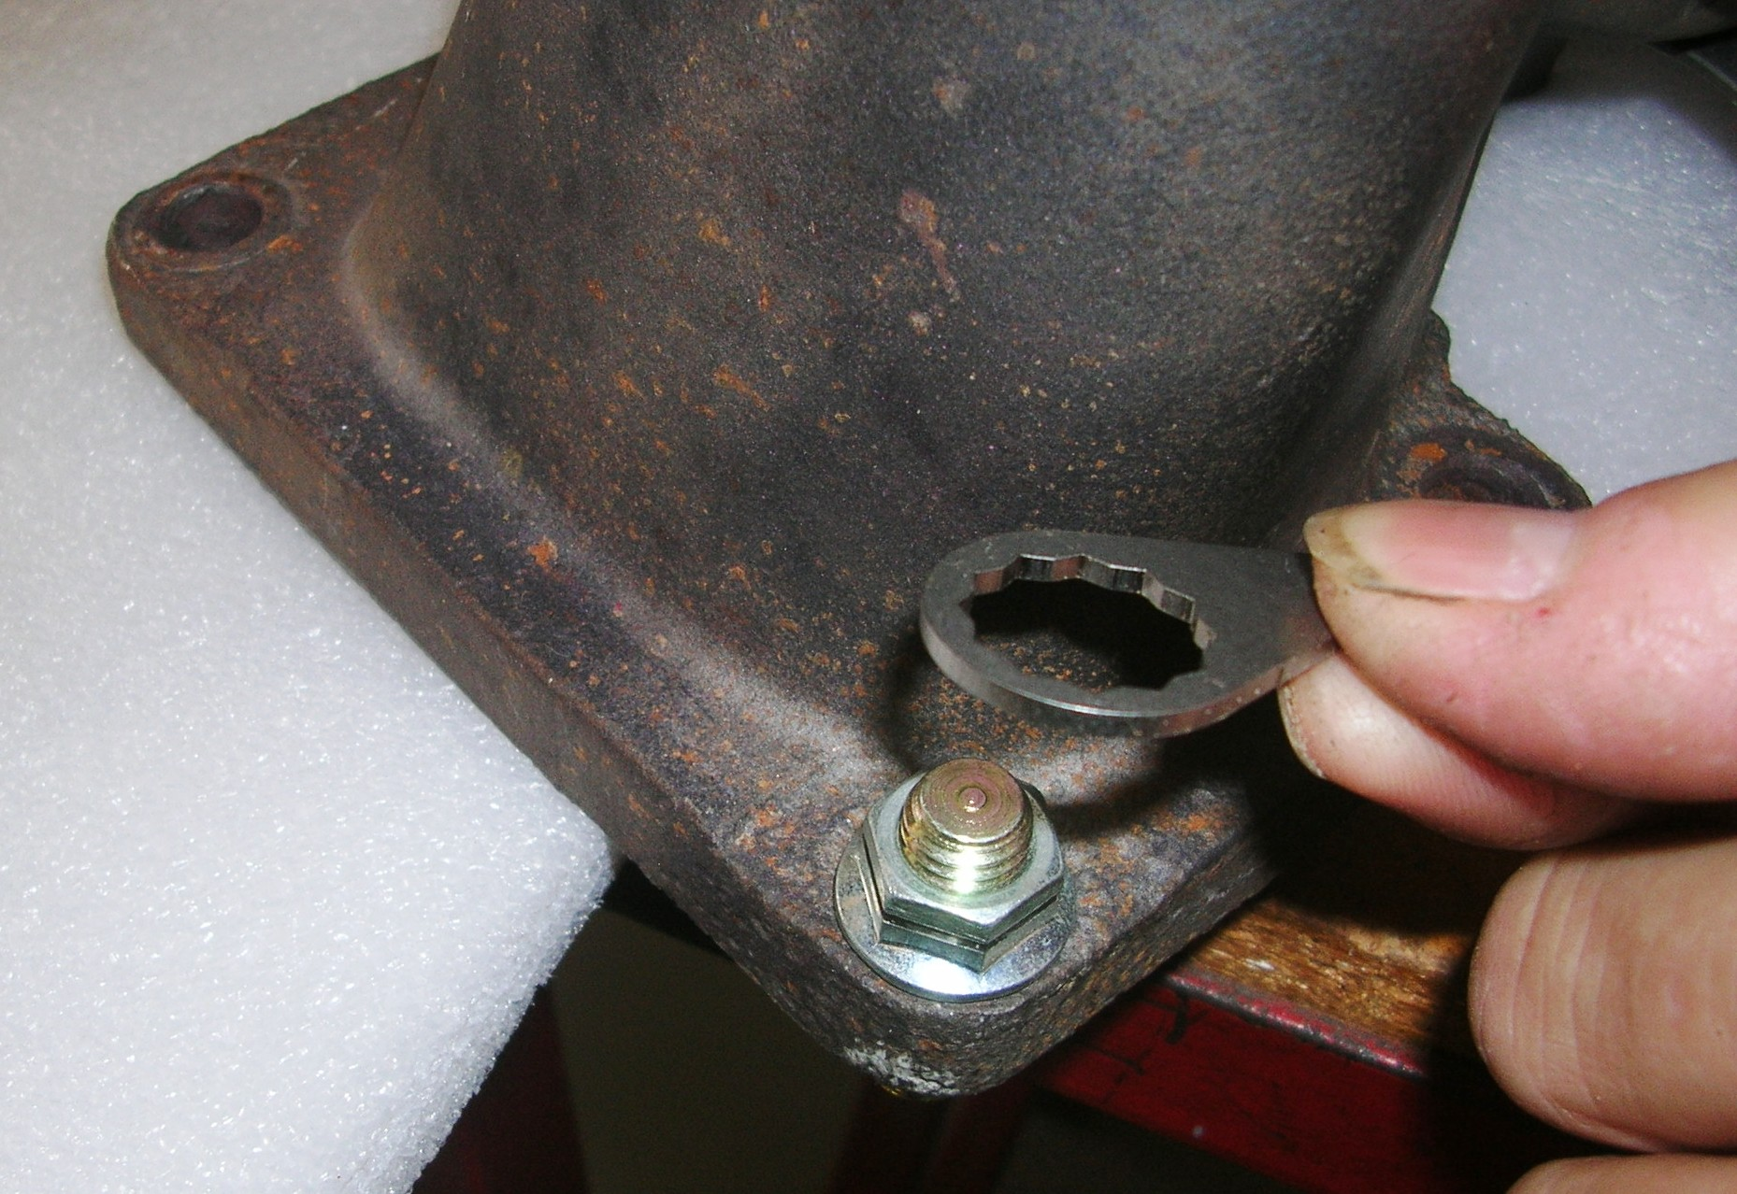
Remove the ducting, oil lines, etc to gain access to the turbocharger. Undo the original studs or bolts that secure the turbocharger to the manifold and remove the turbocharger and the studs. Inspect the faces for corrosion, warpage etc and rectify as required.

Step 2. Place a new gasket between the manifold and turbo and refit the turbo. Install the Anchorlox bolts and torque to 48-50 Nm.

Step 3.
Place an abutment tab over the Bolt on the RIGH HAND SIDE of the body of the turbocharger housing, as viewed from above. Refer Picture above. The tab must be installed in this position so it stops the anti-clockwise rotation (loosening) of the nut. NOTE: It may be necessary to file the side of the abutment tab(s) slightly to allow a tight fit up against the side of the turbocharger, etc.

Step 4.
Fit the C-clip into the groove in the Bolt, securing the abutment tab in place – refer pictures.
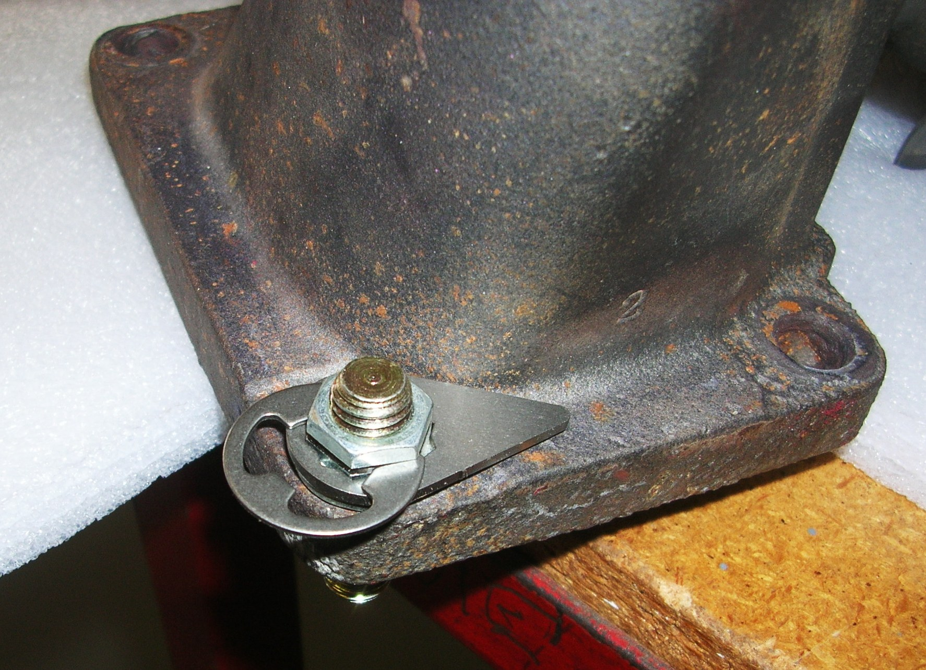
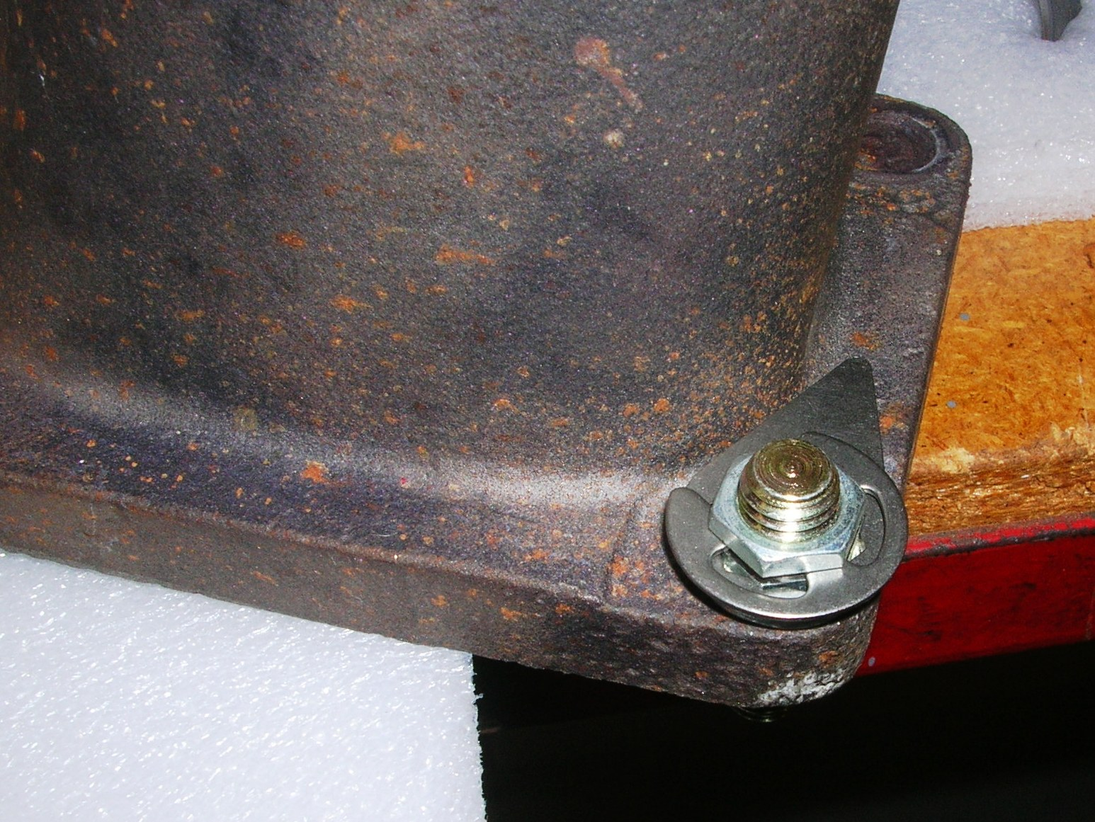

Step 5. Repeat steps 3 and 4 for the remaining studs and refit the turbocharger piping in reverse order of removal.

Remember, if you encounter any problems whatsoever when installing these parts, please call Atomic direct - we are here to help! Cheers,

The Team at Atomic

