Installation instructions and specifications for Atomic Roller Rockers
Part #306581-24

Thank you for purchasing a set of Atomic Roller Rockers. They have been manufactured using advanced manufacturing techniques, premium quality materials, machined to the highest standards and undergo numerous pre and post production checks to ensure these standards are maintained.

To enjoy trouble free operation it is imperative the correct installation procedures are followed. Failure to follow these instructions may lead to failure of the component and/or damage to the engine.

Step 1
Rotate the engine until the timing marks line up with the teeth on the cam drive sprockets (also known as VCT sprockets). This may take up to 36 revolutions until the timing marks migrate to the correct locations. Remove the camshafts from the engine, noting the position and orientation of each cam and the cam saddles/caps. They must be refitted in the same position and facing the same way as originally fitted. Lock tensioner into the retracted position.

Step 2
Remove the OE lifter/rocker arm assemblies. Remove the lifters from the rockers by lightly twisting the lifter to the side. Fit up one new Atomic rocker to the first lifter and place back into the cylinder head in its original location. Repeat with all lifters and rockers. Lubricate all rollers with engine oil.

Step 3.

Reinstall the camshafts and check the lifter preloads – we recommend no more than 1.0mm (.040”) preload to achieve correct lifter operation. The less the preload the higher the lifter will rev before pumping up. (.3mm to .6mm preload is the target range). Refit cam sprockets, chain and then release the tensioner. Ensure motor turns over freely by hand.

NOTE: Please be 100% certain you have refitted the cams to their original positions – FYI the inlet cam has a notch cut-out of the CENTRE of the rear cam sensor cap on DOHC engines. The EXHAUST has the cut-out at the end of the cam sensor cap. Refer pictures below.

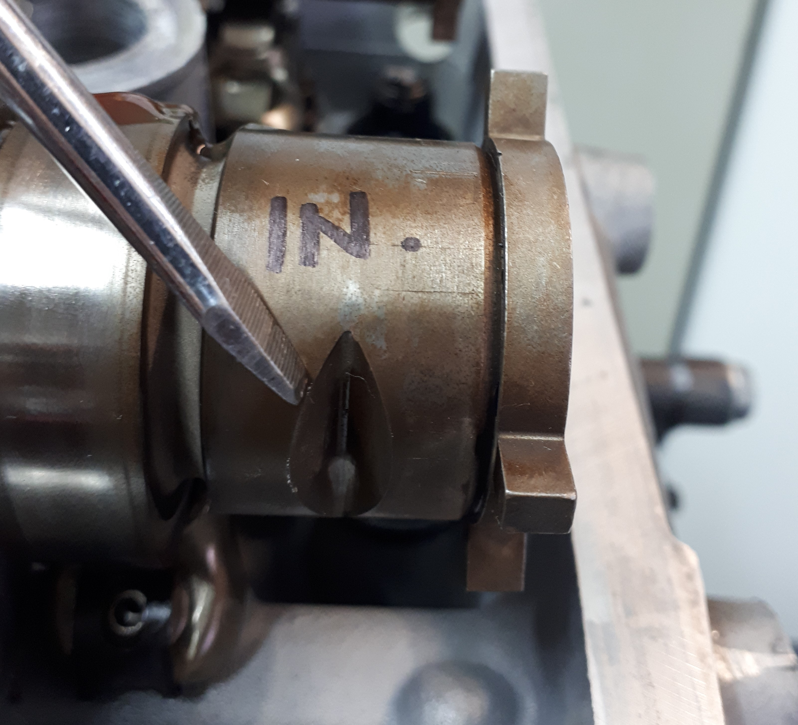
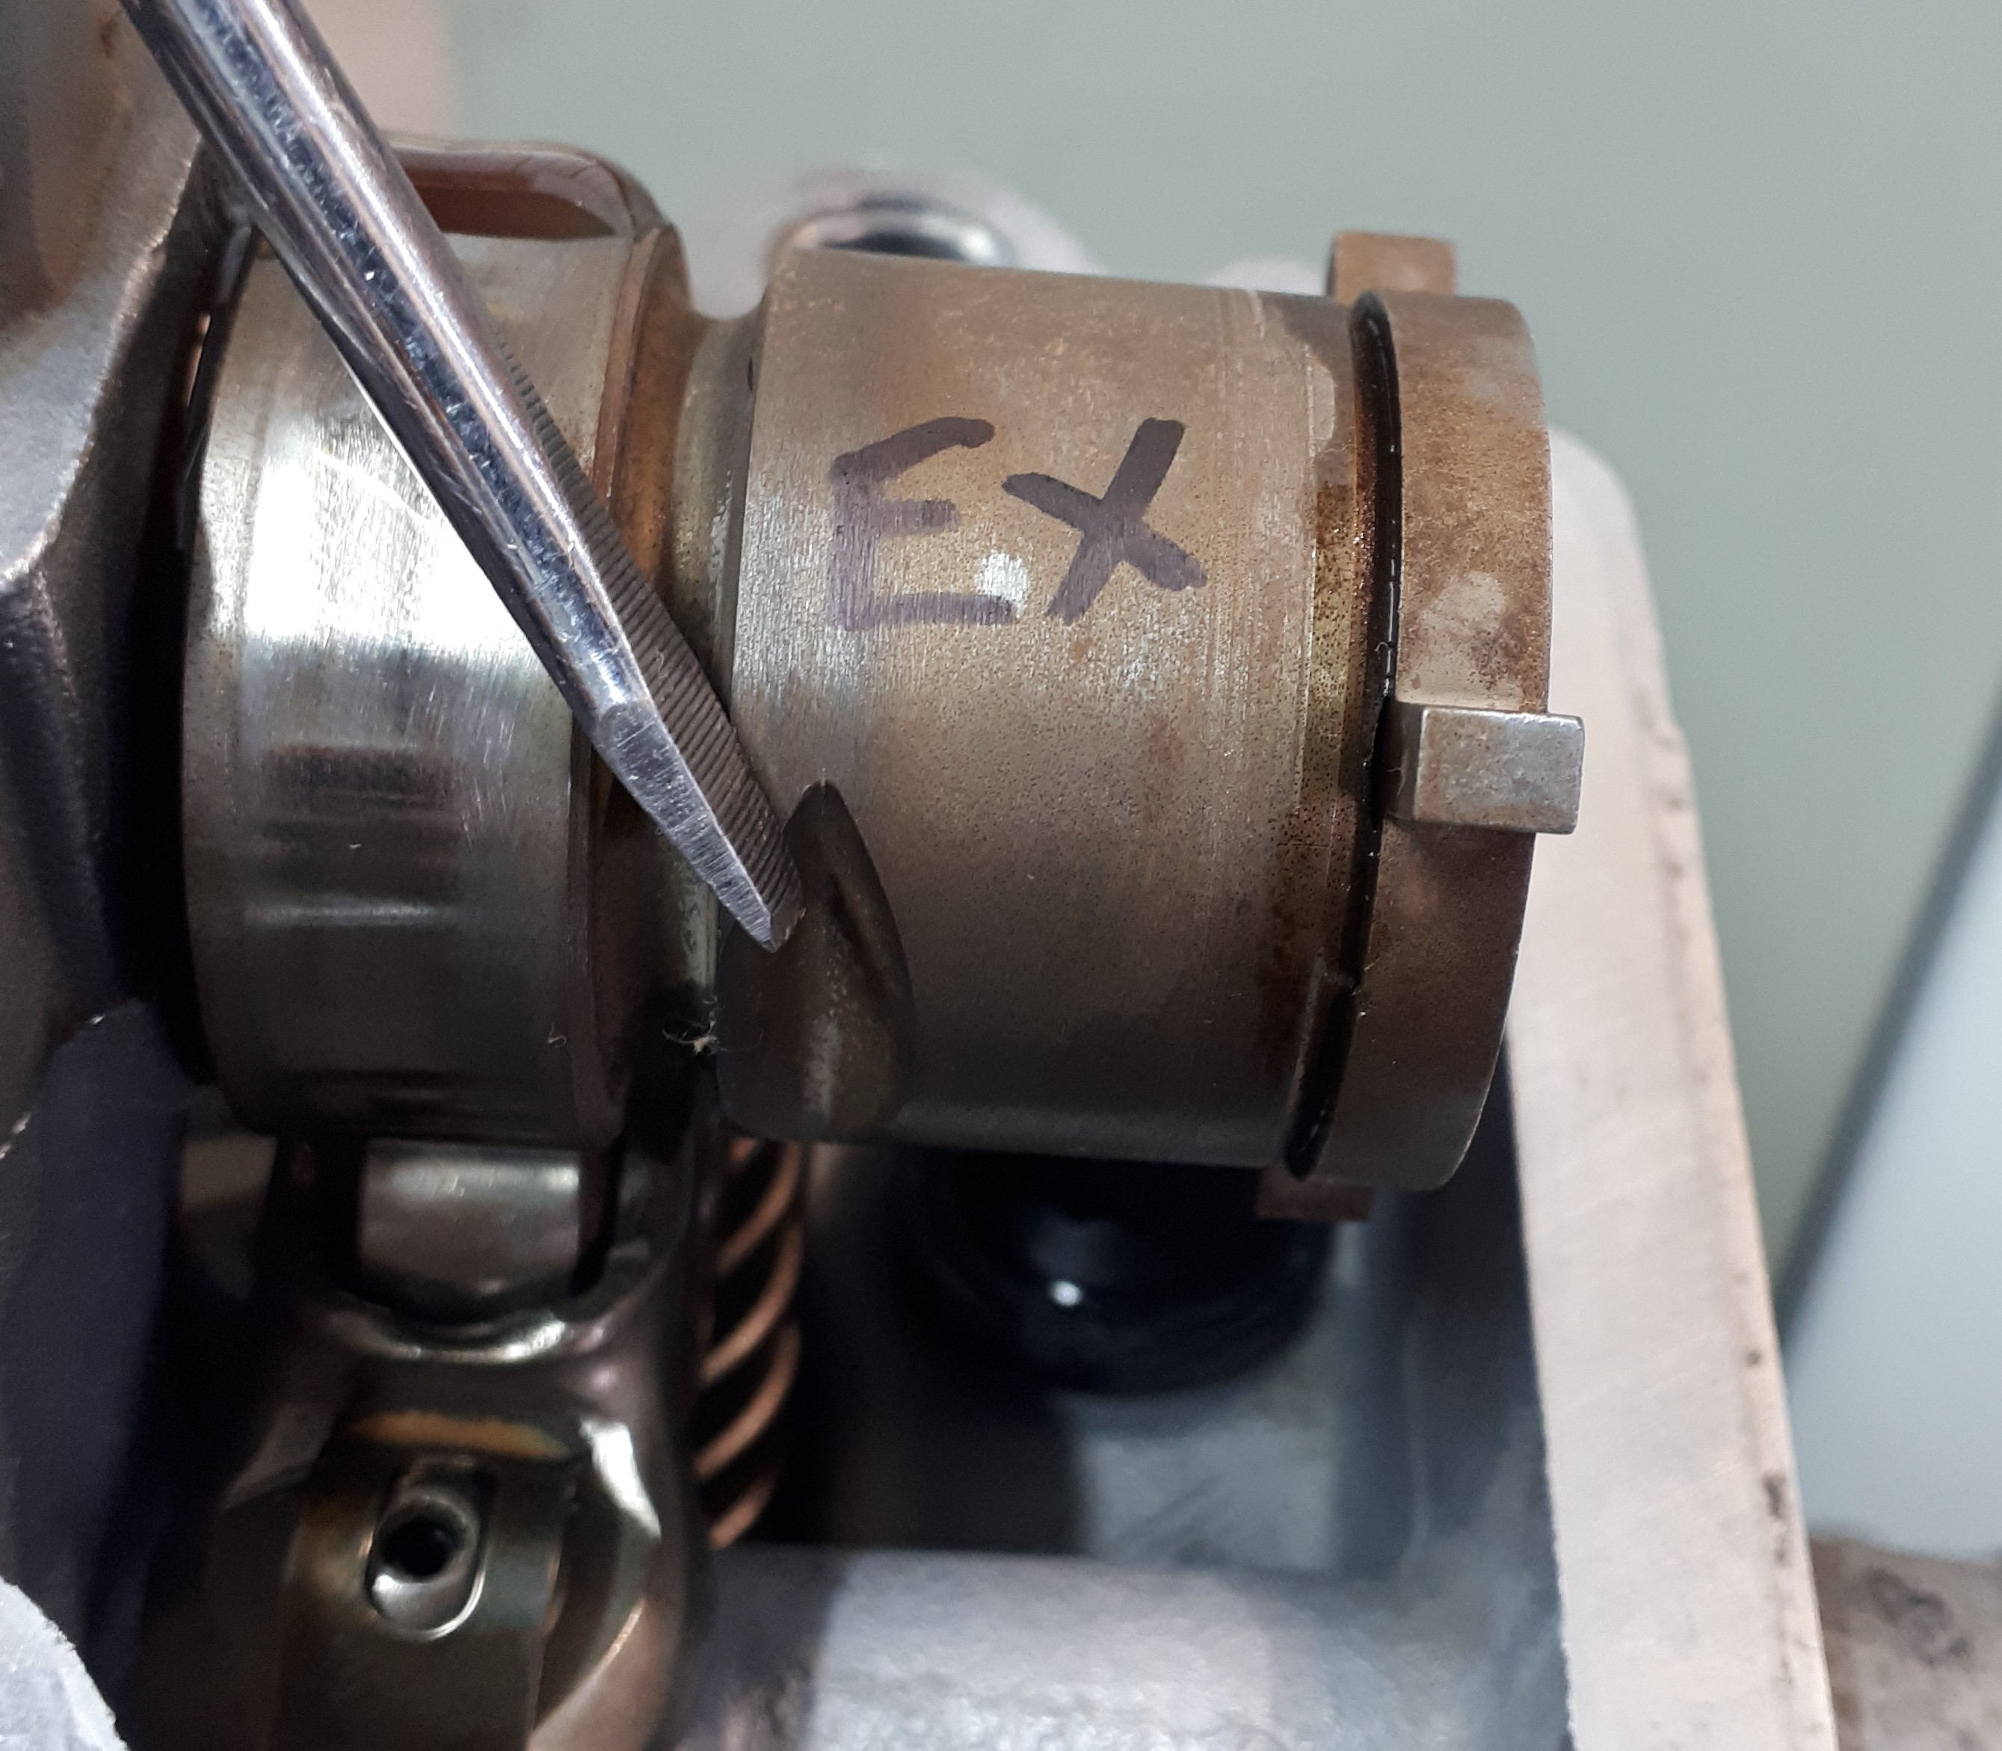

Step 6.
Refit the rest of the ancillary equipment Check all hoses and restart the engine. Please note if you have installed new Atomic lifters it can take up to 1 hour of running before the lifters have filled with oil and the valvetrain is quiet.

NOTE:
Due to the higher reciprocating weight of the rocker arm, valve spring pressures may need to be increased accordingly. The same applies if the valve weights are increased.
To compensate for the increase in rocker arm reciprocating weight, experienced engine builders will often go to Titanium retainers, which typically reduce valvetrain weight by 5-6 grams.

If you encounter any problems whatsoever with the installation of any of our parts or have any questions about Ford DOHC or SOHC 6 cylinder engines in general, please call Atomic direct - we are here to help!

General Rocker arm information:

- Rocker ratio: 2.05:1
- Roller tip to lifter pocket dimension/length: same as standard rocker
- Centre roller diameter/width: Same O.D as OE/13% wider than standard rocker
- Centre roller wall thickness: increased by 20% over standard roller
- Centre roller needle bearing package: 36% more needle rollers than standard rocker
- Total rocker weight: 102 grams (27% increase over stock rocker weight 80grams)
- Tip weight: +13.0 grams over standard rocker
- Valve guide length: 4.5mm (provides additional 1.5mm clearance to valvespring retainer compared to stock rocker)
- Lifter preload dimension: minus 0.3-0.4mm compared to standard rocker.

