Installation instructions - #306563-M Posi-stop timing chain tensioner
to suit Ford Barra 6 cyl engine.

Thank you for purchasing an Atomic product. To enjoy trouble free operation, it is imperative this product is installed correctly. Failure to do so could result in irreparable damage to your engine.

PLEASE NOTE: As the Posi-Stop tensioner is longer than the standard tensioner, a small amount of clearance grinding is required on the inside of the timing cover for clearance. The tensioner WILL NOT FIT if this clearance is not provided. DO NOT SHORTEN THE GRUBSCREW TO BYPASS THIS OPERATION OR THE TENSIONER WILL NOT WORK COPRRECTLY.

Step 1.
Remove the harmonic balancer and the timing cover from the engine and rotate until the timing chain marks have lined up with the crank and camshaft sprockets and the engine is at TDC.

Step 2.
Remove the timing chain tensioner by removing the bolts that secure it to the cylinder head. The driver’s side (adjustable) guide will now be loose, as is the timing chain.

Step 3.
Fit up the #306563-M tensioner by way of the new high tensile bolts that are included with the tensioner. Use a small amount of Loctite 222 on the threads and tighten to 20 NM.
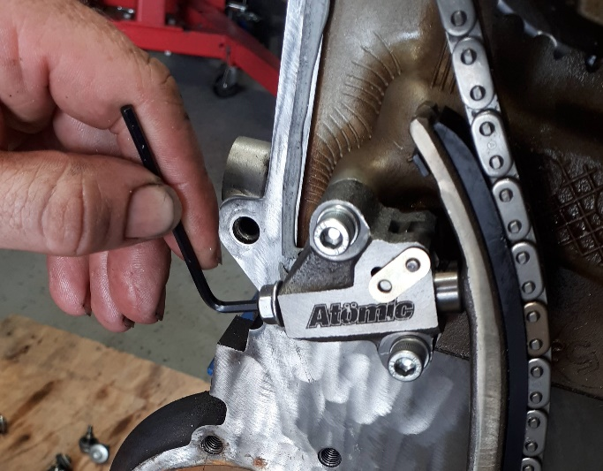
Step 4.
Remove the plastic locking tabs from the tensioner. The piston will move outwards and contact the back of the adjustable guide. Rotate the engine 90 degrees clockwise, then anticlockwise by 180 degrees, then back to TDC (clockwise). This is to ensure the tensioner is fully extended against the back of the adjustable guide and that any slack in the chain has been removed.
Pic #1 above.
Step 5.
Push the timing chain (at the point just above the top of the tensioner) with your thumb to ensure there is still a small amount (3-4mm) of movement of the chain.

THE CHAIN SHOULD NEVER BE SUPER TIGHT. DO NOT PUSH THE TENSIONER OUT OR LEVER THE GUIDE OUTWARDS – let the tensioner find its own natural position. FYI, there is no “correct“ number of clicks the tensioner is to be extended to as it varies from engine to engine.

Step 6.
Wind the M6 grub screw in by hand until you can feel it bottom out against the back of the piston. Turn the grub screw an additional 1/8 turn only and lock in place with the M6 flange nut (provided).
Refer Pic #1 Check there is still 2-3mm of chain deflection available by moving the top of the guide outwards.

Note: DO NOT JACK THE TENSIONER PISTON OUT WITH THE GRUBSCREW!

THE GRUBSCREW IS A “POSITIVE STOP” FOR THE PISTON TO REST UPON WHEN BEING PUSHED BACK BY THE CHAIN, SO THE RATCHET PAWL DOES NOT HAVE TO CARRY ALL OF THE LOAD OF THE CHAIN AND GUIDE.

NOTE: If the chain is too tight it will make a gear whirring sound. To rectify this, reset the tensioner as per steps 4 to 6 above.

Step 7.
Clean the inside of the timing cover and remove any residual sealer on the seal faces. Mark out a line 107mm from the corner of the timing cover and scribe a line perpendicular to the gasket face.
Refer pic #2 below

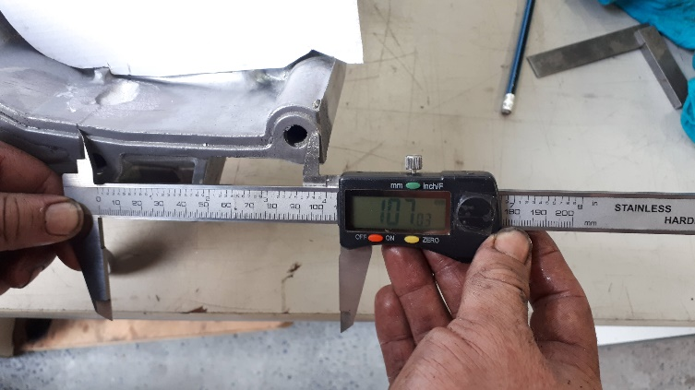
Step 8.
Using a die grinder, grind a small relief in the back of the timing cover from the front inside face of the cover. The relief is a teardrop shape, and the approximate dimensions are 15mm wide, 5mm deep and 25mm long. It is not necessary to break through into the timing cover bolt hole. If you do so you will likely have an oil leak. Refer Pic #3

Step 9.
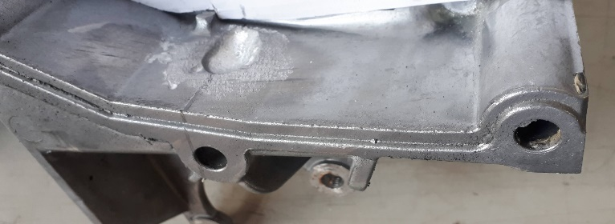
Trial fit the timing cover to ensure the teardrop relief is sized correctly for the adjusting screw and locknut, then refit the cover, using the OE dowels and the appropriate gaskets. Pic #3

Note #1: The tensioner is fitted with an M6 grub screw that is of an appropriate length to work in most applications, however if the block and or the head has been decked appreciably, it may require the use of a 5mm longer grub screw (supplied in the kit). Also, there may be a slight audible operational noise when using the Posi-stop tensioner.

Note #2: Please be careful when removing the wire or plastic locking tabs from the tensioner. Due to the asymmetrical teeth design of the ratchet and the stronger spring pressure, the piston can dislodge itself from the tensioner body if allowed to be released without the piston being retained.
If this occurs, the tensioner can be reassembled easily.

Remember, if you encounter any problems whatsoever when installing these parts, please call Atomic directly - we are here to help!

Cheers, The Team at Atomic

