Instructions for installation of #306503 Aircon compressor delete/idler kit.

Thank you for purchasing an Atomic Aircon delete/idler kit. To enjoy trouble free operation it is imperative these instructions are followed carefully – failure to do so could lead to ineffective operation and the possibility of severe engine damage.
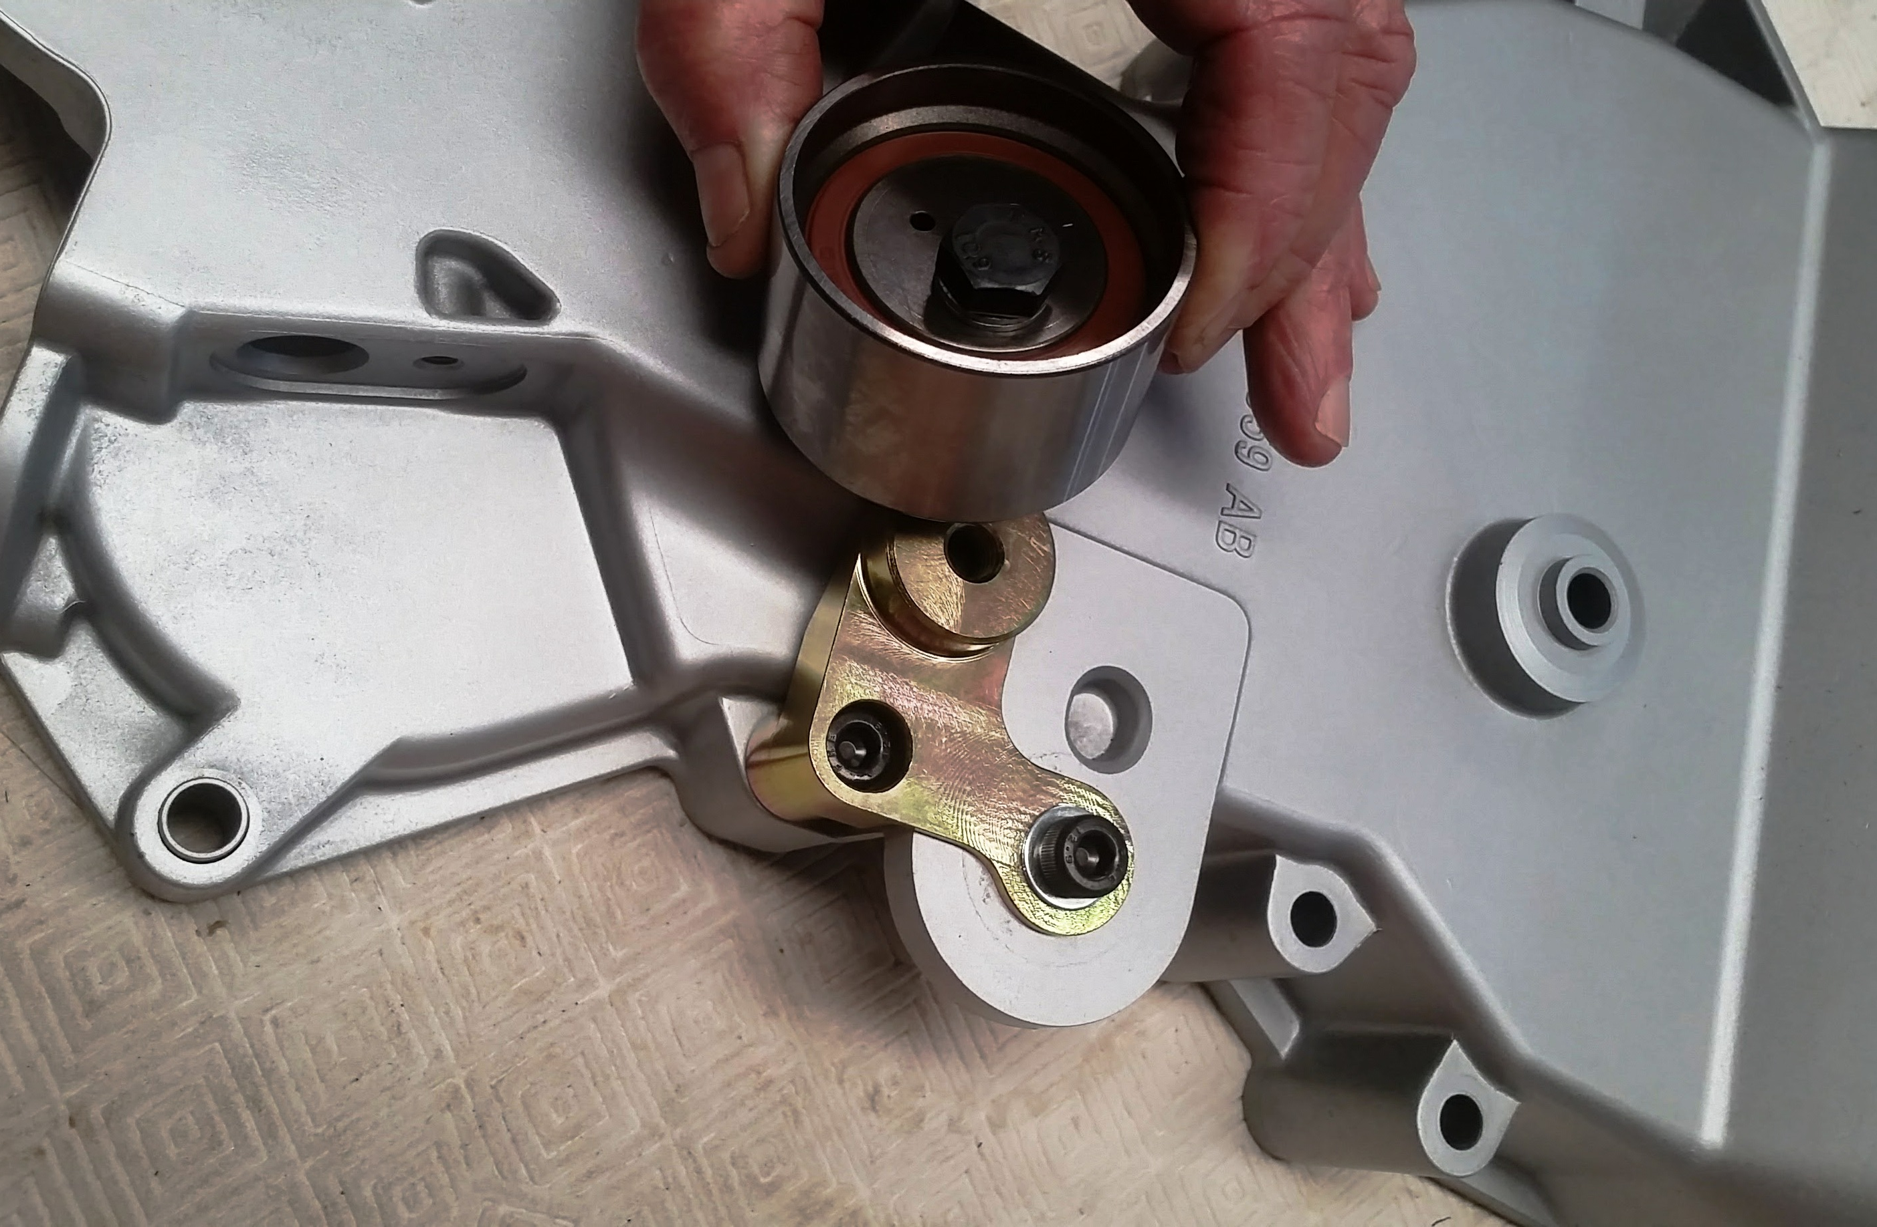
Step 1.
Remove the Aircon compressor and the spring-loaded idler.
Step 2.
Remove the M8 timing cover bolt from next to the lug that the factory adjustable idler bolts to.
Step 3.
Mount the Atomic billet mounting plate to the timing cover, using a M8 x 75mm capscrew through the long M8 clearance hole and a M8 x 20mm capscrew and washer through the short M8 clearance hole. Tighten to 25 NM. Note the position of the bracket in the photo. Also, please refer to the installation video on our YouTube channel.
Step 4.
Mount the eccentric adjustable pulley to the circular lug on the billet mounting plate by way of the M10 hex head bolt and locking washer. Tighten finger tight only at this stage.
Step 5.
Refer to the following belt length table and purchase the appropriate length belt from your local auto parts supplier. Note that the belt should be a relatively snug fit onto the pulleys BEFORE the adjuster is tightened – this is due to the limited amount of travel (and therefore tension) available from the eccentric idler adjuster. NOTE: In some unusual cases it may be necessary to use a +/-10mm belt than listed below.
Belt length table

Balancer | Alternator | H2O pump | P/Steer pump | Belt Length
Stock Ford Balancer | BA | Stock H2O pump | Ford P/steer pump fitted | 6PK1645
Atomic Race balancer – std speed | BA | Stock H2O pump | Ford P/steer pump fitted | 6PK1640
Atomic/ATI Super Damper | BA | Stock H2O pump | Ford P/steer pump fitted | 6PK1595
Atomic Race balancer – 15% underdrive | BA | No H2O pump | Ford P/steer pump fitted | 6PK1300
Atomic Race balancer or STD balancer. | BF/FG | Stock H2O pump | Ford P/steer pump fitted  (with alternator 63.5mm dia) | 6PK1655 or  6PK1660
Atomic/ATI SuperDamper | BF/FG | No H2O pump | No power steer - #Atomic #306504 delete fitted | 6PK1300
Stock Ford balancer | BF-FG | Stock H20 pump | Atomic #306503 Aircon delete and #306504 & power steer delete kits. | 6PK1625
Step 7.
Rotate the eccentric into the belt and tighten the M10 hex bolt to 35 NM once the correct belt tension is achieved. Start engine and check pulley operation. Recheck after one hour’s operation.

Remember, if you encounter any problems whatsoever when installing these parts, please call Atomic direct - we are here to help!

