Instructions for installation of Atomic Forged pistons.

Thank you for purchasing Atomic forged pistons. To enjoy trouble free operation it is imperative the pistons and rings are installed correctly - failure to follow these important points will lead to ineffective operation and the possibility of severe engine damage.

Point 1.
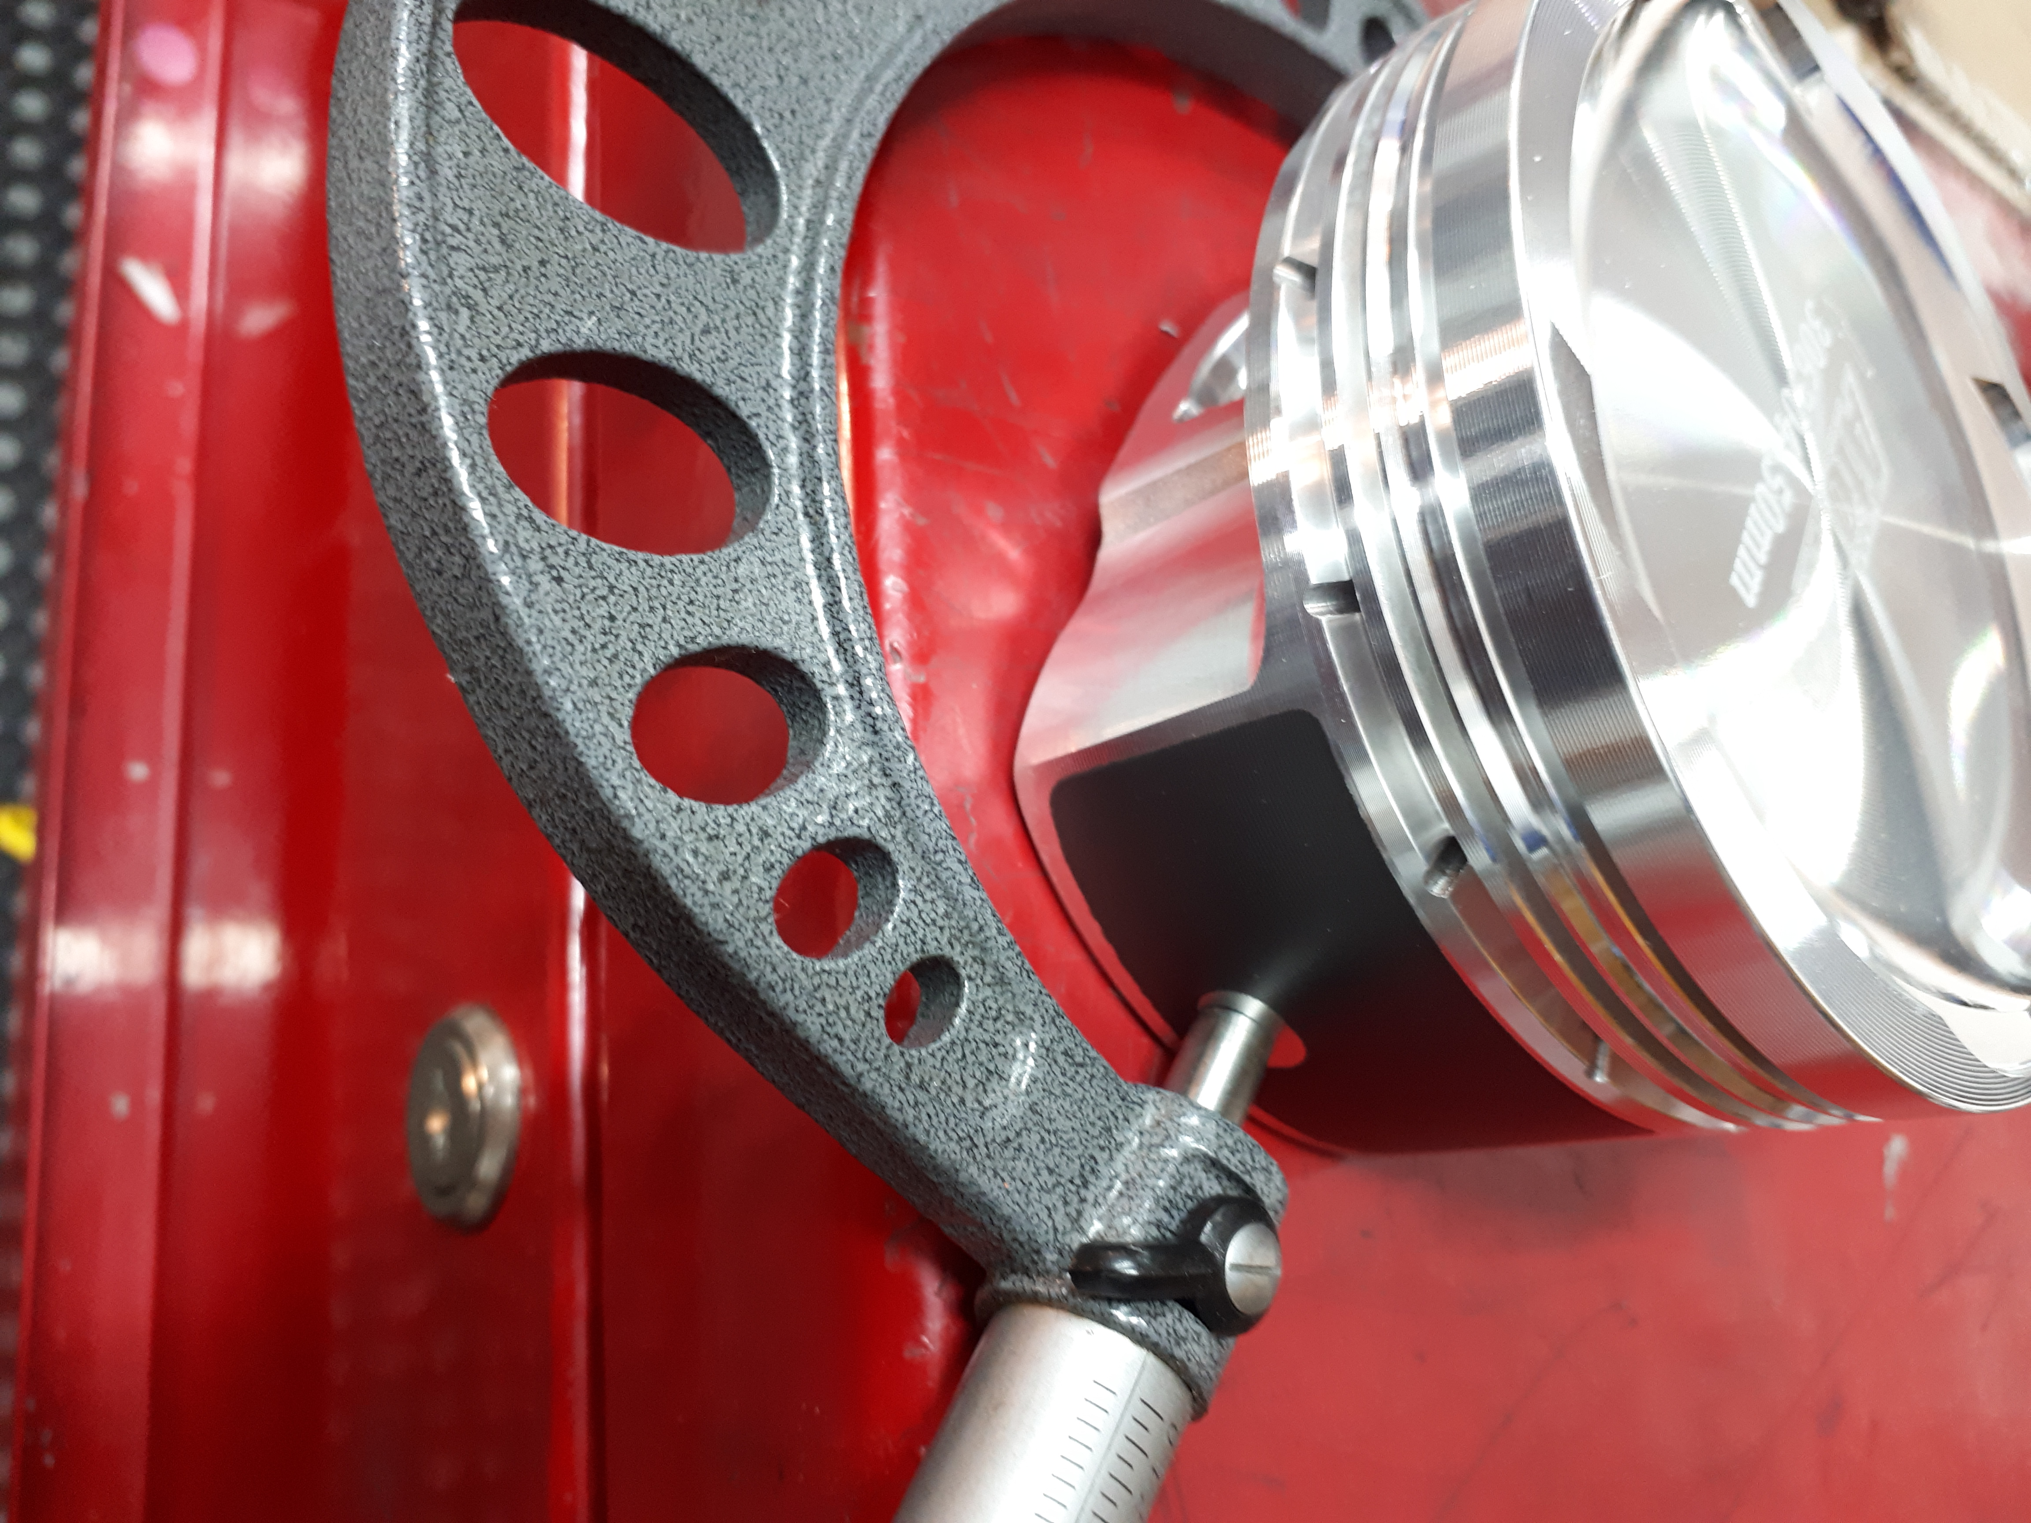
The FINISHED bore size is to be a minimum of .004” GREATER than the diameter of the piston as measured at the specific NON coated positions on the skirts. Please note an additional .001” to .0015” piston to bore clearance is recommended when using partial grout filling of the coolant passages.

Point 2.
It is strongly recommended that a torque plate be used when finishing cylinder sizing to produce a concentric and straight bore when the cylinder head is torqued on place. Suggested plateau finishing is with a #320 grit stone.

Point 3.
The rings are FILE-TO-FIT and must be checked individually and the end gaps filed to suit each individual bore. We recommend a clearance of .006” per inch of bore diameter for the top compression rings (steel) and .0065” for the second compression ring (iron) for all applications, including forced induction.

Point 4.
The gudgeon pin eyes in the pistons have been honed to size so no further machining is required. The pins are 9310 material with .200” wall and are matched to the pistons.

Point 5.
The arrow on the top of the piston is to face towards the FRONT of the engine. This is very important as the piston has pin offset. Extreme operational noise will be created by improper installation.

Point 6.
Please note our pistons come with 4 valve notches however it is still important to check the piston to valve clearance when using non-standard cams and/or altered cam phasing. This is the responsibility of the installer.

Point 7.
Before final assembly, thoroughly wash the pistons with solvent to ensure cleanliness and blow dry – under no circumstances use a rag to wipe the pistons or pins. Lubricate with engine assembly lube.

Point 8.
The positioning of the ring end gaps is as follows (as viewed with the pistons installed din the engine)

- TOP RING: 5 O’clock
- SECOND RING: 10 O’clock
- OIL EXPANDER: 7 O’clock
- OIL RAILS: 2 O’clock and 4 O’clock

The use of a tapered ring installer is recommended, however conventional style ring compressors work well also.

Remember, if you encounter any problems whatsoever when installing these parts, please call Atomic direct - we are here to help!
Cheers, The Team at Atomic

