Installation instructions for #306250, 251, 252, 253 and 254 Main cap Girdle.

Thank you for purchasing a quality Atomic product. It has been manufactured using premium quality materials, machined to the highest standards and undergoes numerous pre and post-production checks to ensure these standards are maintained. To enjoy trouble free operation it is imperative the correct installation procedures are followed. Failure to follow these instructions may lead to failure of the component and/or engine damage.

Step 1.
Drain the engine oil and remove the sump from the engine. Remove the oil pickup, windage tray (if fitted) and main cap bolts, leaving the main caps in place.

Step 2.
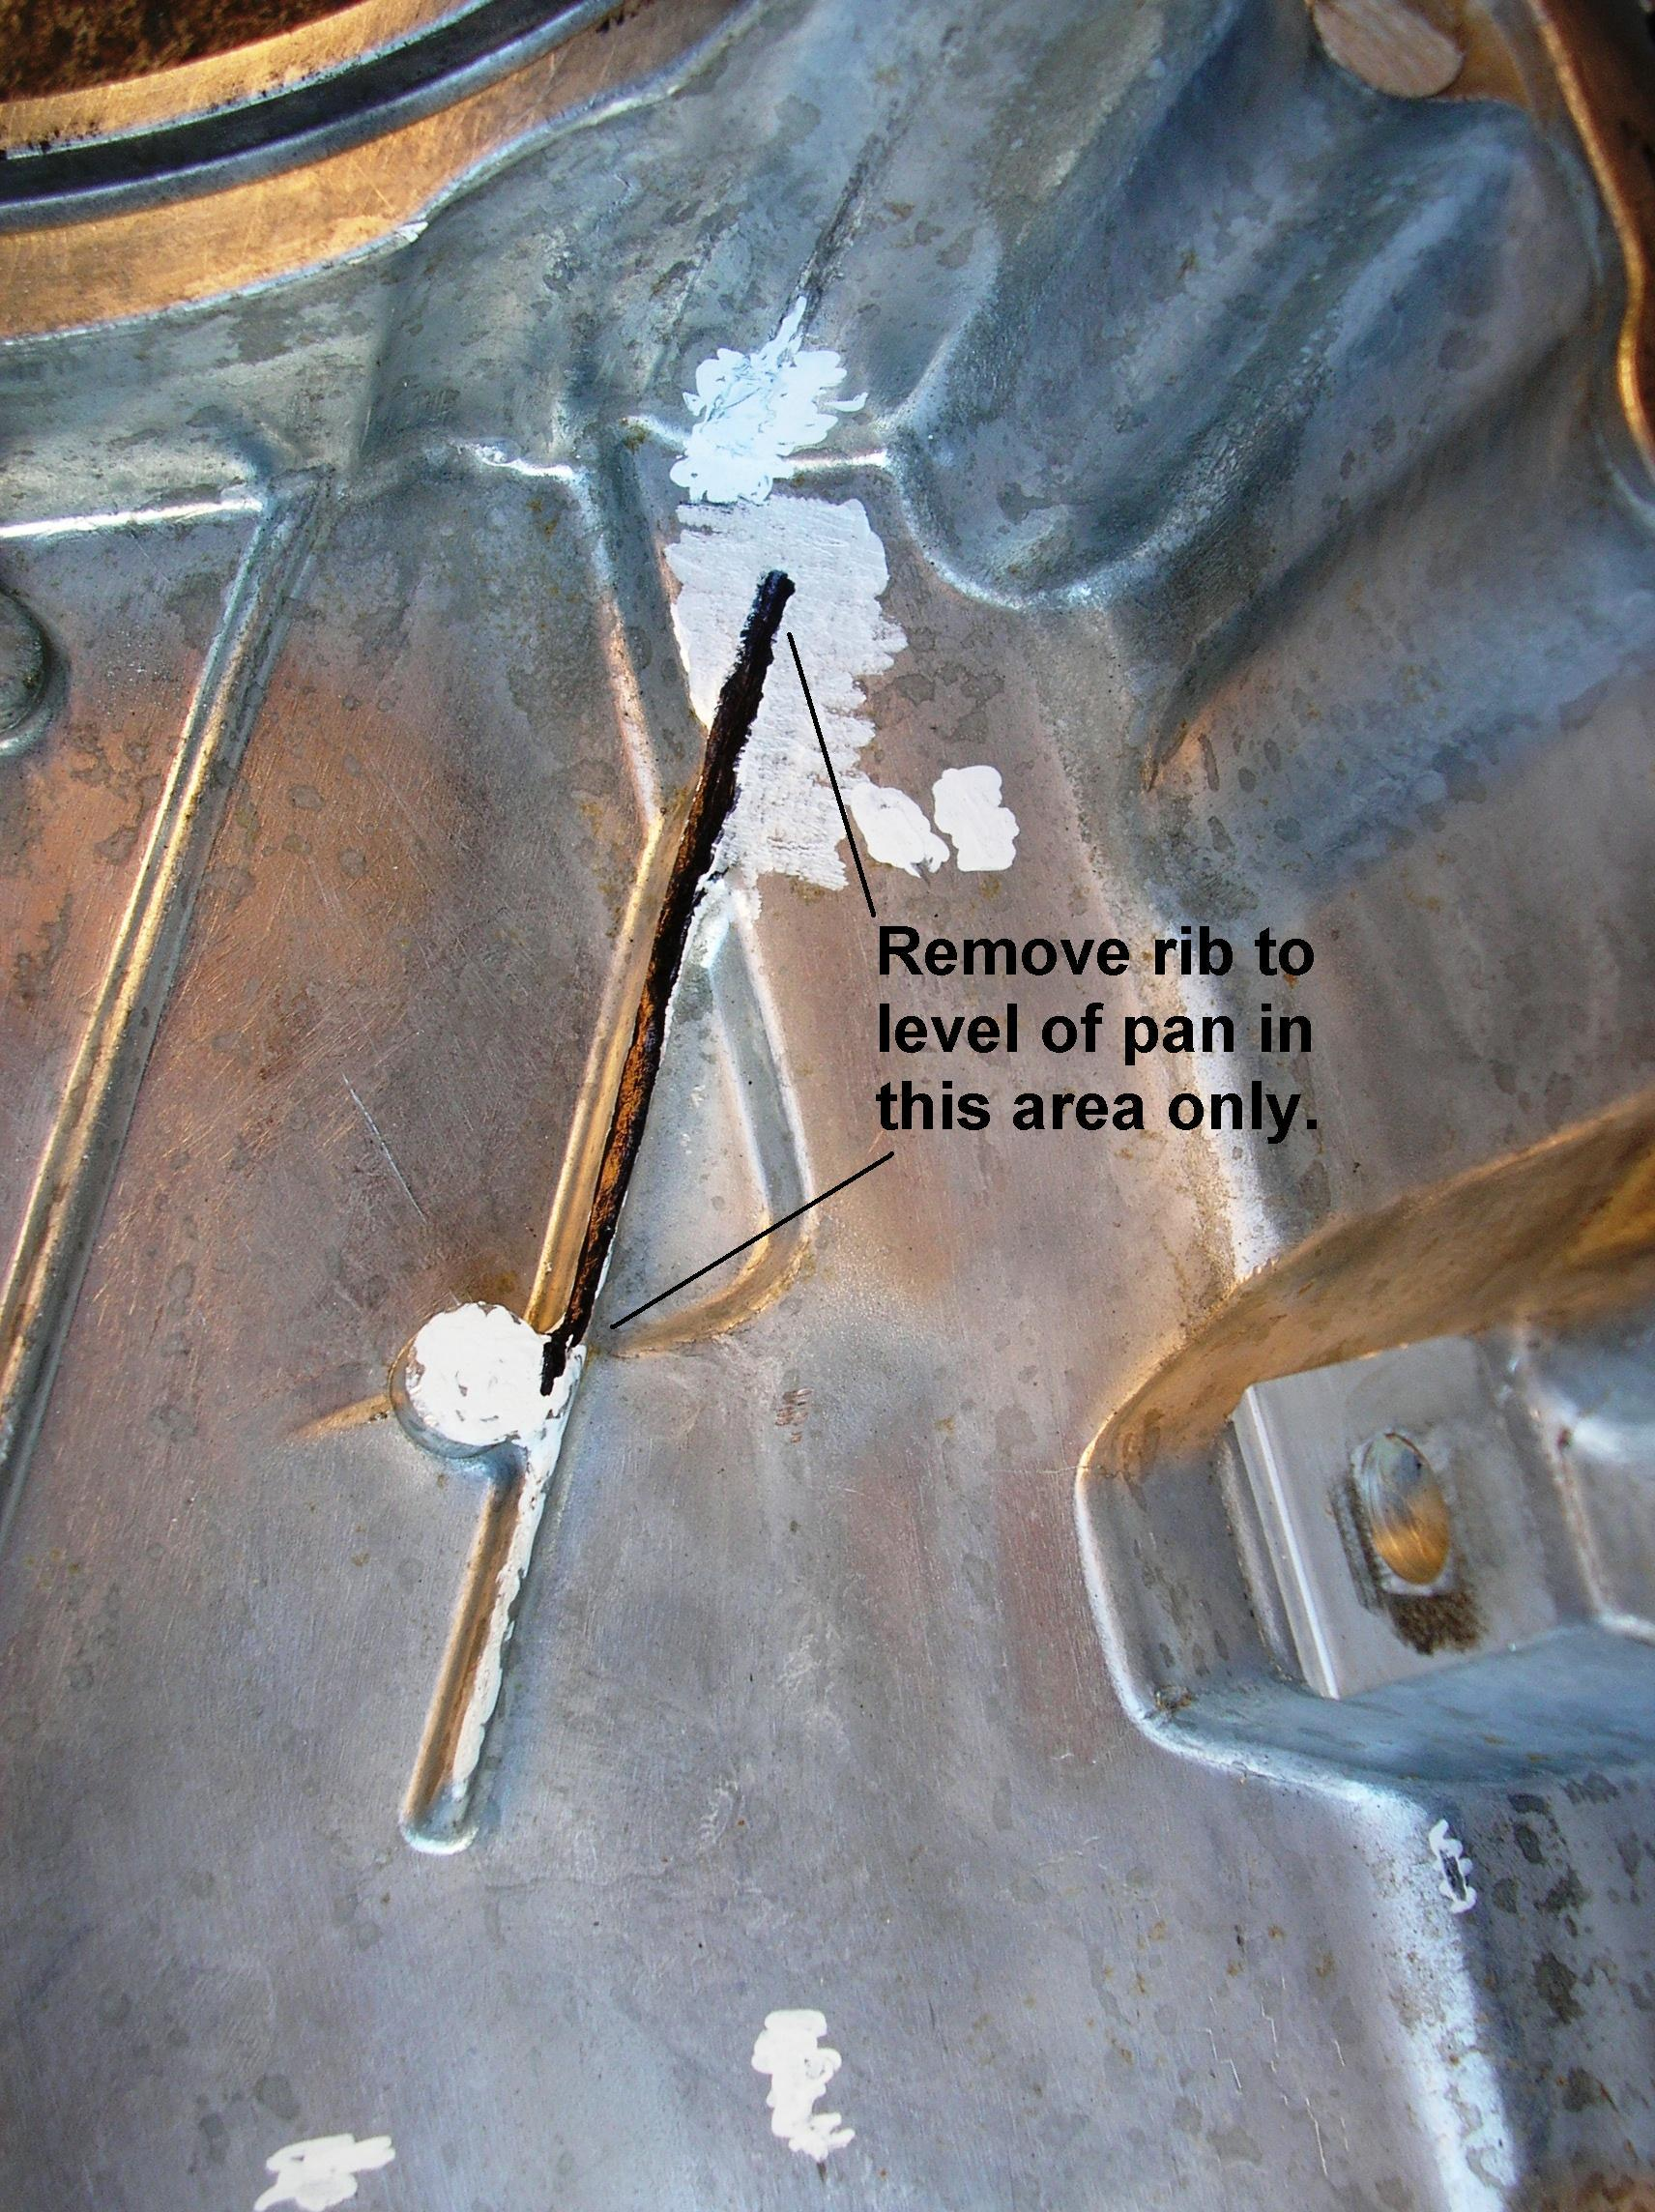
DOHC Engines.
Bolt up the main cap support girdle to the engine, following the instructions (on the face of the girdle) which notes the correct way the girdle is to be fitted. Fit windage tray in place OR prepare your existing tray for fitment by drilling out the spot welds and remove the 2 x steel support straps located under the tray. (SEE NOTE D), then fit the tray on top of the girdle, torquing the bolts to the appropriate torque specifications. The OE bolts are 80 NM or 59 Ft.lbs. and the torque for Atomic main studs is 100 NM or 75 Ft lbs when the girdle is fitted.

Step 3.
DOHC Engines.
Fit the oil pickup, paying close attention to its fitment in relation to the main support girdle – the girdle/windage tray must not inhibit the pickup from being refitted to its original location. Slight adjustment to the louvres on the windage tray may be required. Ensure there is at least 12-15mm clearance between the oil pickup and the bottom of the sump.

Step 4.
DOHC Engines.
Trial fit the sump without any gaskets to see if the sump fits flush against the block. If not, check the inside of the sump to see if there it has a large cast strengthening rib cast in place (as shown in picture at right). Not all Ford sumps have this rib and if it is present it may need to be reduced in height to the same level as the body of the oil pan, in the spot marked on the image.
This is easily accomplished with a die grinder and a rotary burr or by hand with a file. Note that some FG sumps may require similar grinding at the rear main oil seal flange - refer picture. Also pay close attention to #6 main cap as some have an oval lug instead of round.

Step 5.
DOHC Engines.
Refit the sump to the engine using new gaskets and/or the appropriate sealer and tighten the sump retaining bolts to 9 Nm torque. Refit the cross bolts with a little sealer and tighten them to 58 Nm.

Step 6.
DOHC Engines.
Turn the engine over by hand to ensure there is no interference between engine components and the girdle, rectifying as necessary. Refill engine with the correct engine oil for your application, restart engine and check for oil leaks.
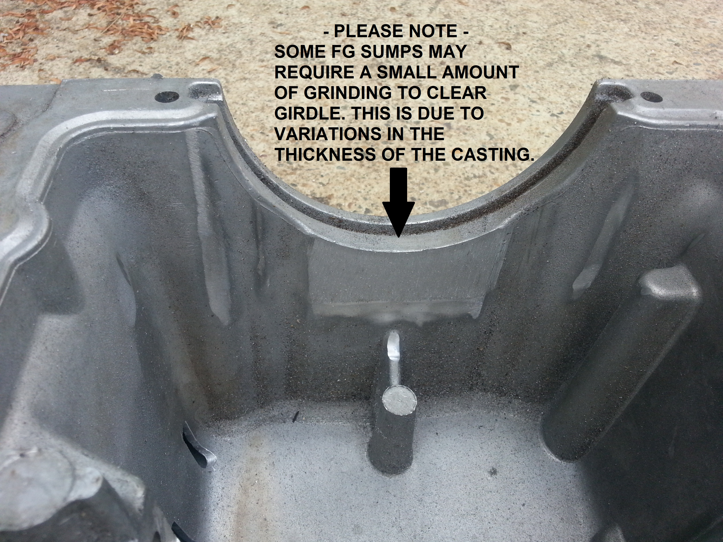

NOTES:
- In DOHC engines, our Race Series girdles require sump modifications to fit, whereas the Street Series girdles will generally bolt up without any modifications to engines made after 9/2003. Engines produced prior to this had a baffle riveted into the sump which must be removed and the mounting lugs cut down by 20mm.

- In SOHC engines, the girdle is fitted to the main caps in the same manner as a DOHC engine, however in engines prior to AU, machined spacers are to be fitted between the girdle and the main cap. 14 spacers are required – contact Atomic for details. Longer main cap bolts are also required. An upgrade to Tool Steel studs is available at extra cost – Atomic part # 306670-SOHC is the kit for the job.

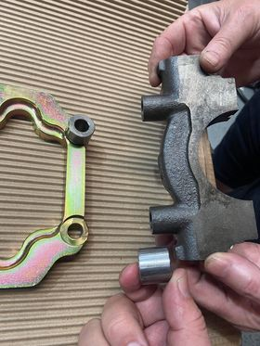
- When fitting a main cap girdle AND a main stud kit to an FG engine it may be necessary to delete the washers from the front 4 bolts (caps 1 and 2). This is due to factory machining tolerance stack-up with the cast sump and the depth to which the main cap bolt holes have been drilled – it varies by up to 10.00 mm.

- In some cases we do not supply the windage tray with the girdle. In these instances, your existing tray can be easily modified to fit. Removal of the 2 steel support plates is required – all you need to do is drill out the 10 to 12 spot welds with a 7mm drill bit, remove the plates and deburr the holes in the tray….refer pics below.

SOHC Caps are not all the same – some require spacers – refer picture above

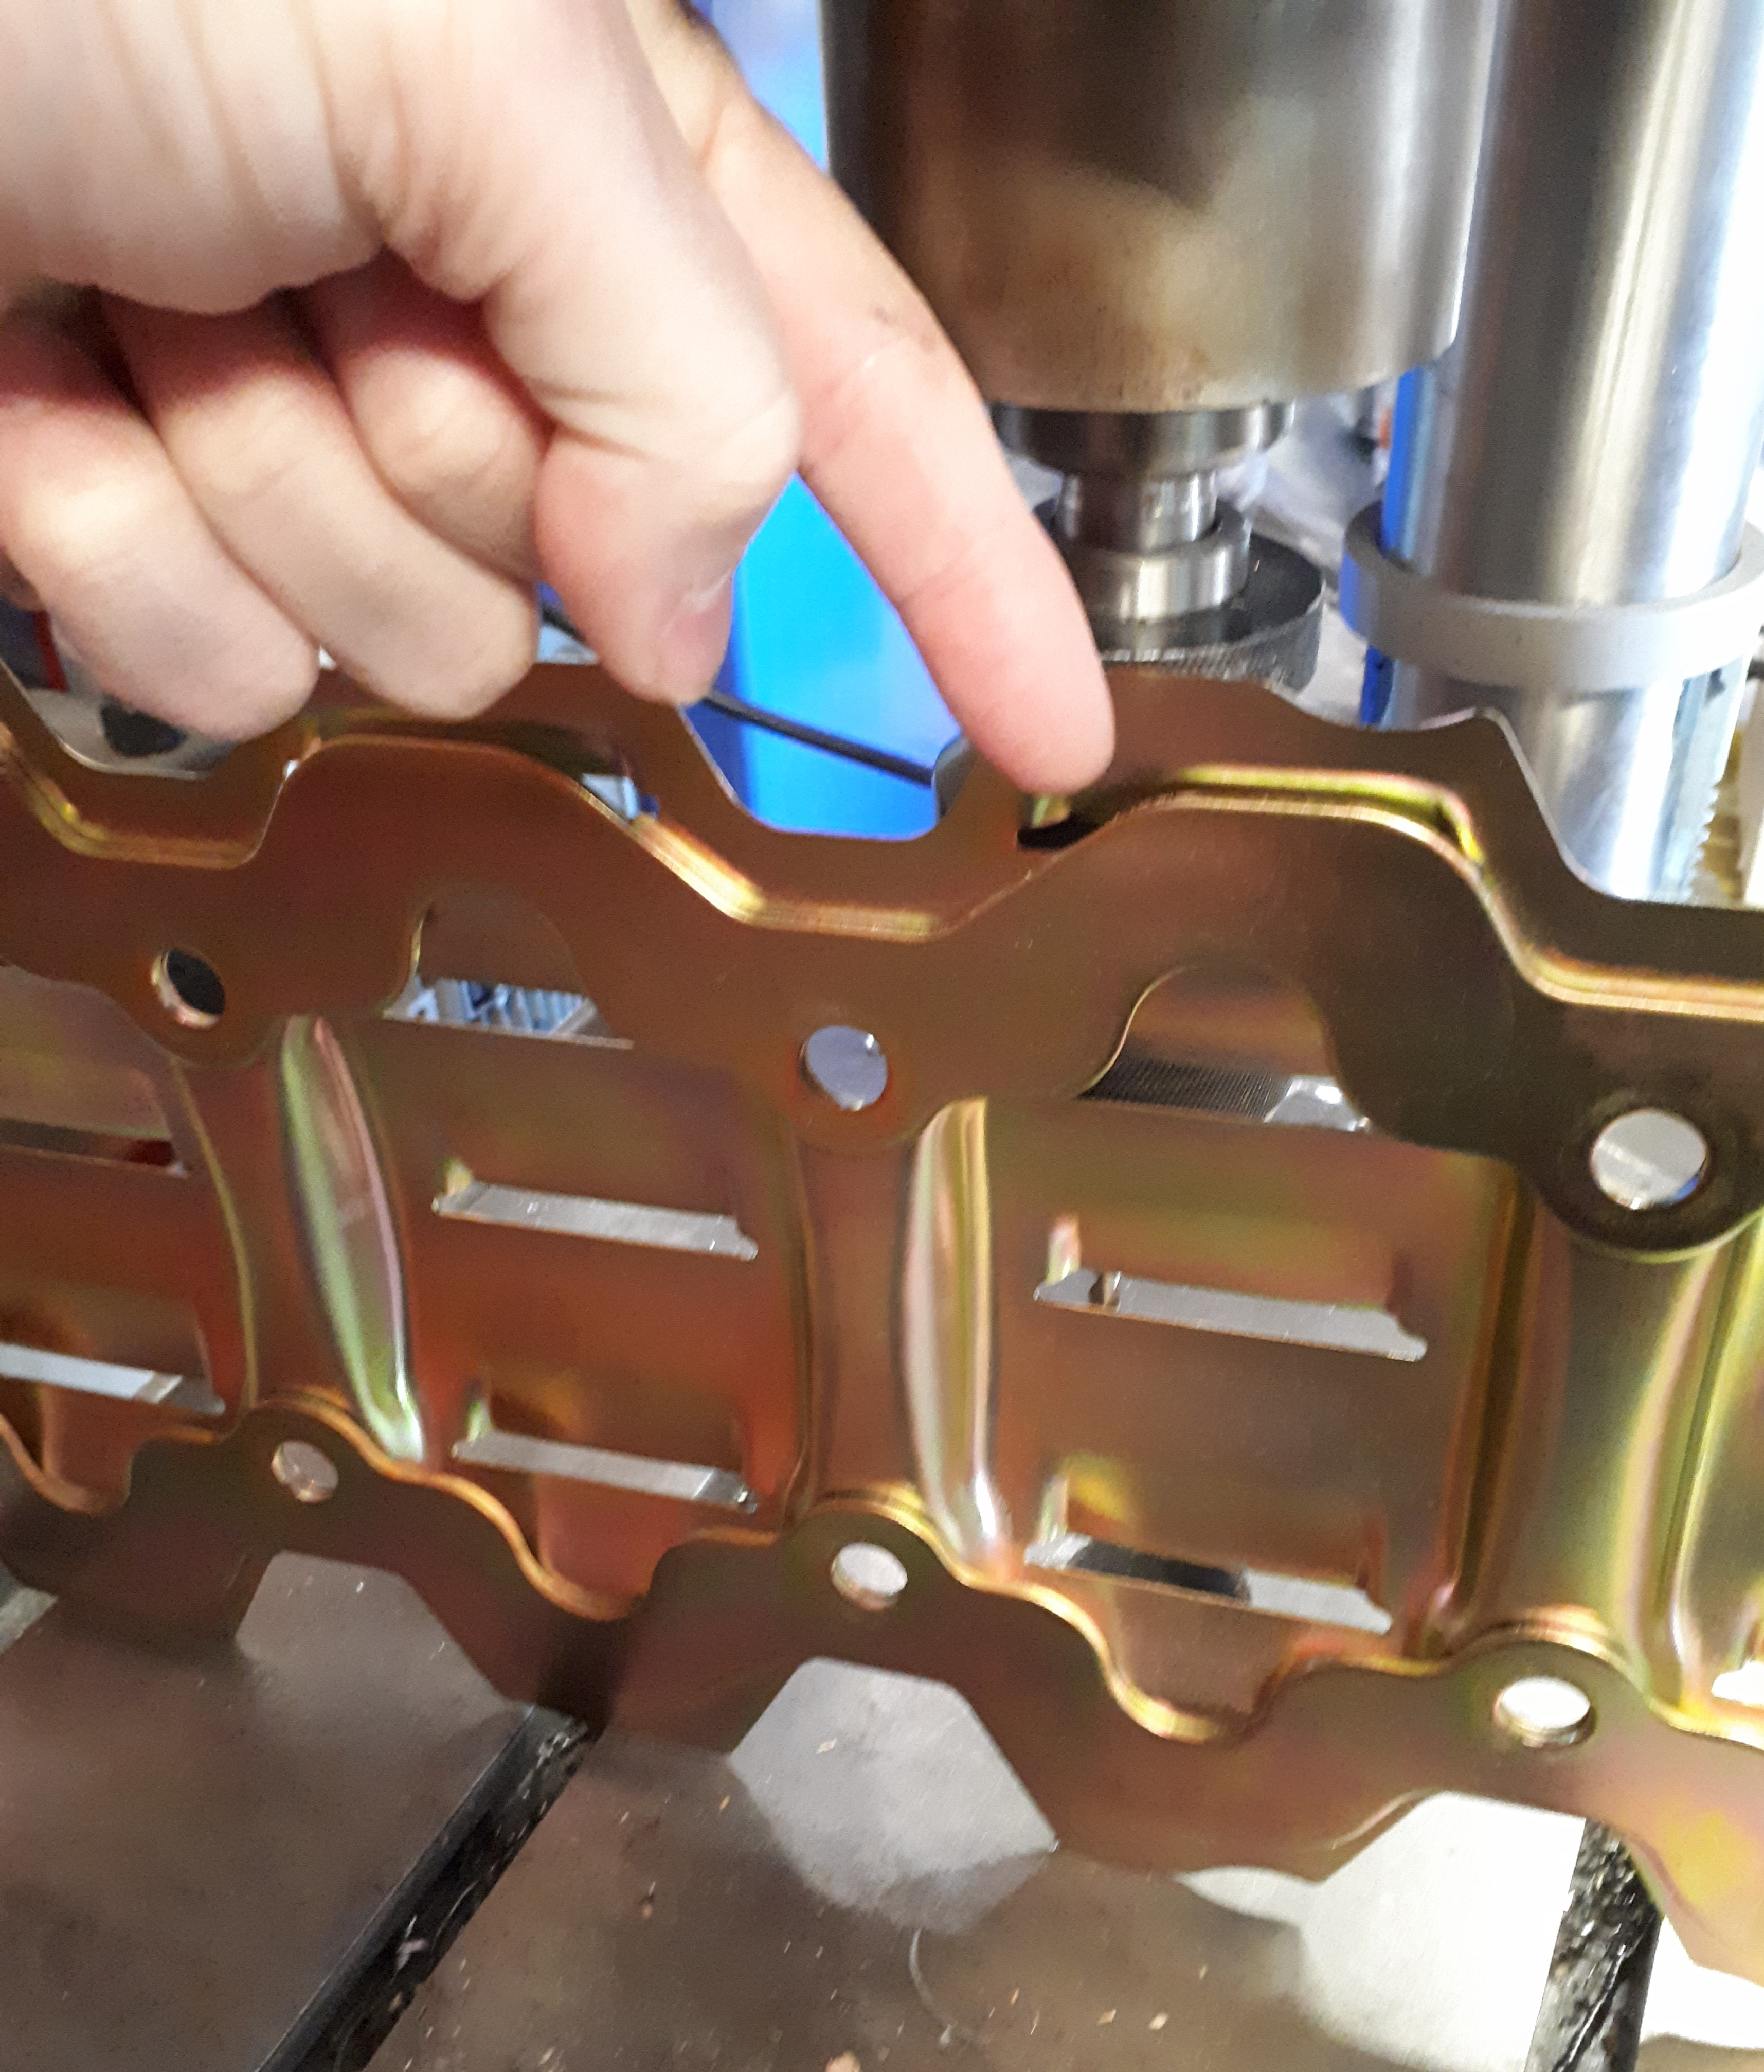
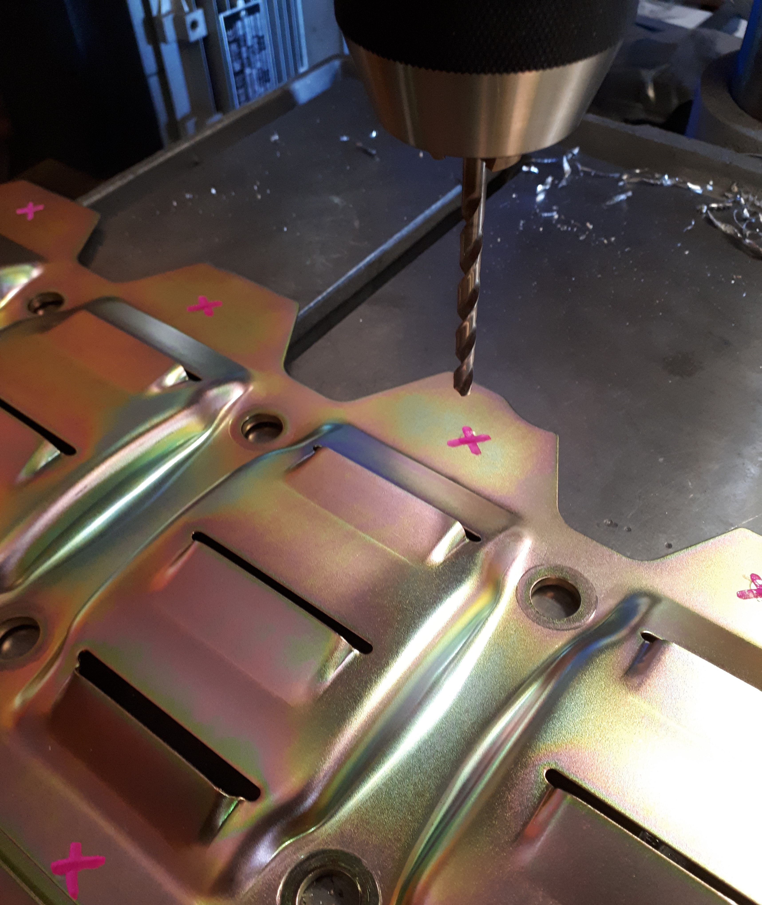

DOHC applications: Removal of these 2 plates is required to fit the windage tray. Drill out the spot welds as shown above.

If you encounter any problems whatsoever with the installation of this product, please call Atomic direct on 02-8665 5889 - we are here to help!

Cheers, The Team at Atomic

