Instructions for installation of #306244-L, #306244-H etc Mechanical Fuel pump kit.

Thank you for purchasing an Atomic product. To enjoy trouble free operation it is imperative the parts are fitted correctly – failure to follow these instructions will lead to ineffective operation and the possibility of severe engine damage.

Step 1.
Remove aircon compressor and associated components from the vehicle.

Step 2.
Fit the mandrel to the harmonic balancer. PLEASE NOTE if you are using Atomic #306244-A, B or C mandrels, the appropriate mounting bolts are included. Torque the countersunk fasteners to 22 NM, using Loctite 222 on threads. Fit the 14-tooth pulley to the mandrel, ensuring the steel key is fitted to the mandrel. Do not fit the belt retaining collar as yet.

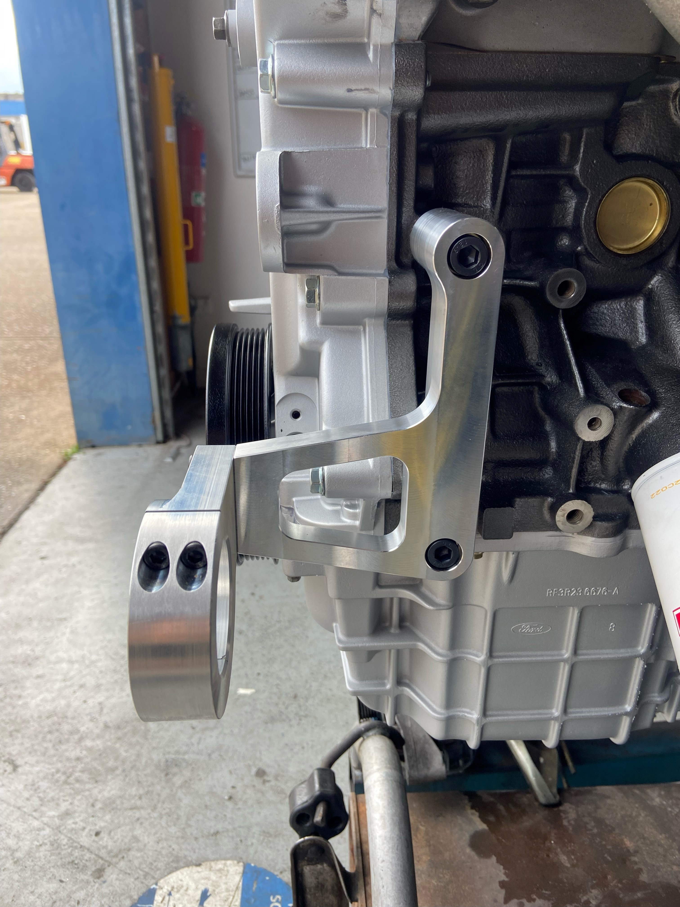
Step 3.
Check fit the pump in the #306244 mounting bracket and then fit the bracket and pump to the engine. See photo #1.

Tighten the M10 mounting bolts to 65 NM. Do not tighten the pump clamp bracket fully as yet – lightly nip up the 4 x M6 bolts. (You need to be able to rotate/align the pump within the bracket for fitment/alignment in the final steps of installation.)

Step 4.
Fit up the 28-tooth pulley to the pump, ensuring the steel key is fitted. Do not tighten the grub screws fully at this stage.

Step 5.
Trial fit the belt on the pump and mandrel by firstly fitting the belt over the 28-tooth pulley and then sliding the belt onto the 14-tooth pulley. Make sure the belt, both pulleys and the pump are aligned correctly. PLEASE NOTE: The belt should have the correct tension once installed – the way to test is to rotate the belt on its axis 90 degrees with your fingers. Please refer to photo #2 below.

If the belt is too tight, a small amount of material needs to be removed from the back of the bracket to reduce the dimension between the pump pulley and the crankshaft pulley. In our experience this additional machining requirement is very remote. Contact us for further details should this issue arise.

Step 6.
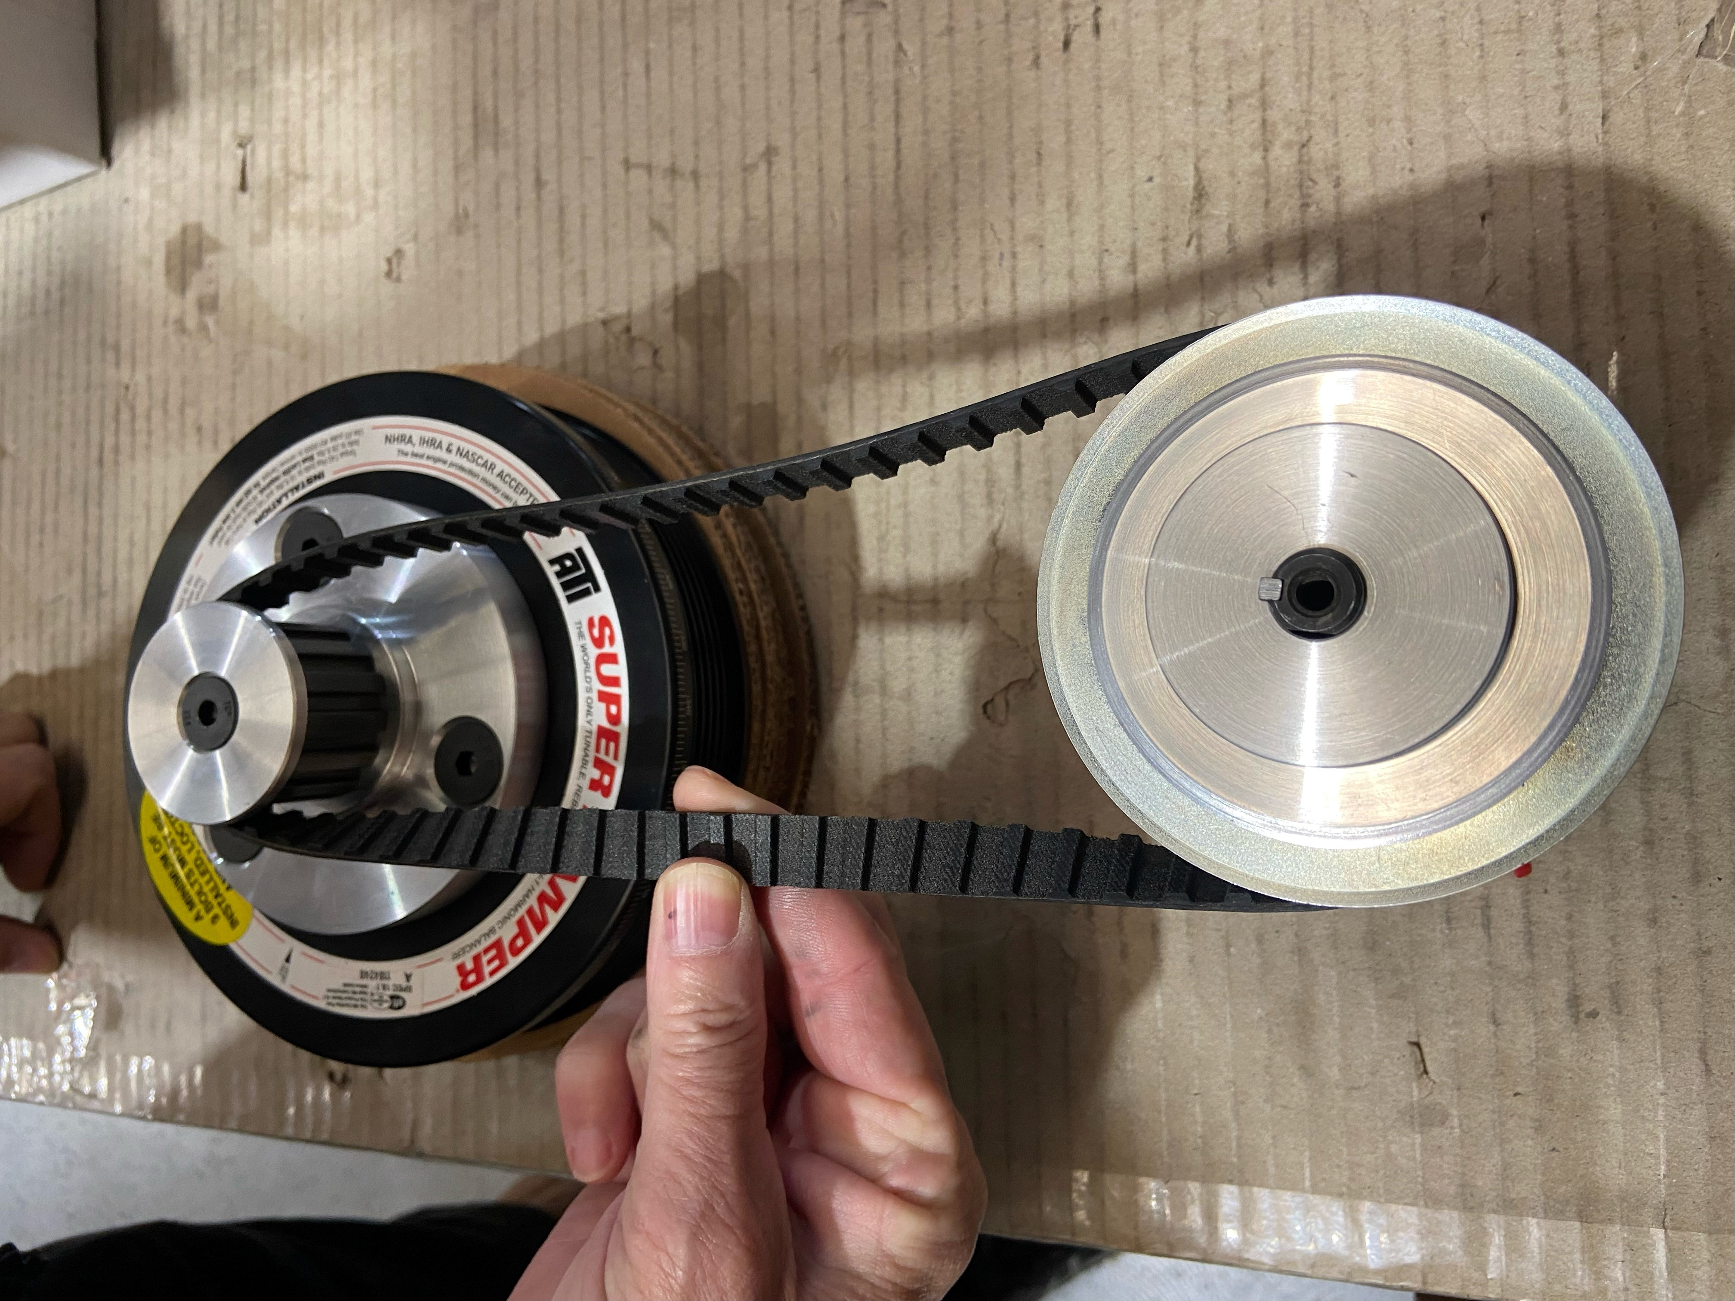
Double check the alignment of the belt and if correct, tighten the 4 x M6 bolts on the bracket clamp to 17NM with a small amount of Loctite 222 or equivalent on the threads. Then secure the 28 Tooth pulley in place with the grub screws provided. Finally, fit up the belt retaining collar onto the 14-tooth pulley and tighten the countersunk allen head bolt to 20 NM with a small amount of Loctite 222 on the thread.

Step 7.
Crank the engine over without spark plugs to check the belt/pulley alignment. If the belt is not in the centre of the 14-tooth pulley, adjust the alignment of the pulleys and/or pump accordingly.

Step 8.
Fit up hoses as required. Please note it is strongly recommended a 15-micron pre-filter is fitted to the pump to ensure no debris enters it.

Remember, if you encounter any problems whatsoever when installing these parts, please call Atomic direct - we are here to help!

Cheers,

The Team at Atomic

