Instructions for installation of #100707 Crossman valve bleeder kit.

Thank you for purchasing an Atomic coolant system bleeder kit. It is designed to suit vehicles that have the radiator located lower than the highest point of the engine and the kit allows removal of trapped air. To enjoy trouble free operation it is imperative the kit is installed correctly - failure to follow these instructions will lead to ineffective operation and the possibility of engine damage.

Please note that mechanical aptitude is required to install this kit.

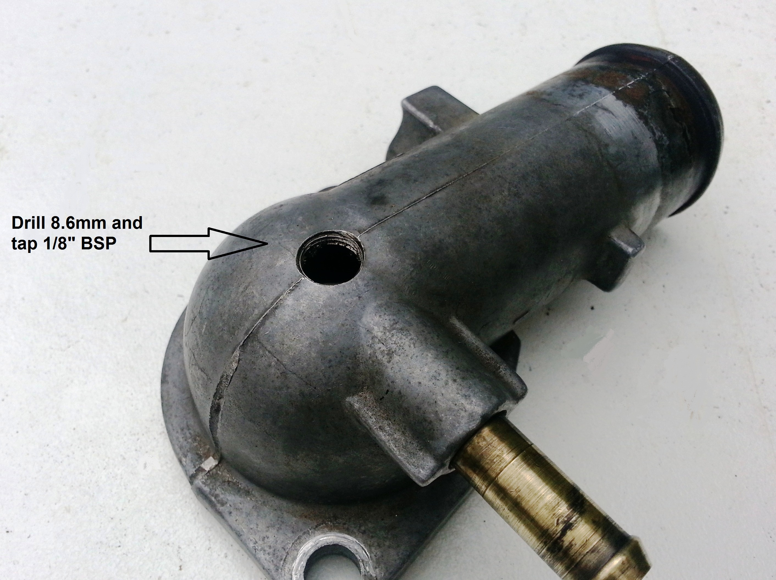
Step 1.
Remove the thermostat housing from the engine. Check for cracks or warpage and replace as required.

Step 2.
Drill an 8.6 mm hole in the top of the thermostat housing and tap with a 1/8” BSP taper tap. Ensure you tap the thread to provide the correct engagement of the Crossman valve – it should be able to be threaded into the housing approx 1/3 of the way BY HAND. Tapping the thread too deeply will result in the valve not engaging correctly in the thread.

Step 3.
Put some of your preferred thread sealer on the threads of the valve and install. Refit the thermostat housing to the thermostat block ensuring the correct temperature thermostat is fitted to suit your application. Atomic #306080 Thermostat (71 deg C) is recommended for performance applications. Ensure the thermostat has a 3.5 mm air bleed hole in the flat section of the body of the thermostat.

Step 4.
Add coolant to the engine, checking for leaks. Start the engine and build some heat into the engine. Open the Crossman valve slightly to allow air to be purged. Check the coolant level in the overflow tank and adjust accordingly. Once all air is expunged from the engine, tighten the Crossman valve – this is best done by using 2 spanners – one to hold the body and another to tighten the needle valve.

Step 5.
Test run the car to ensure the operating temperature is correct. Recheck coolant level the next day.

Remember, if you encounter any problems whatsoever when installing our products, please call Atomic direct - we are here to help!

Cheers,

The Team at Atomic

